Master North Star Business Plan
Date: 2025-09-07

Master North Star Business Plan

Date: 2025-09-07

Executive Summary
This business plan presents a complete, investor‑grade strategy for creating, optimizing, and preserving a multi‑entity enterprise whose purpose is to compound cash flow and equity while minimizing taxes and isolating risk. The model integrates three operating vehicles—ToriMedia as the creative and intellectual property engine, Neat Circle as the packaged solutions and optimization engine, and the SuiteDash Business Operating System as the universal workflow and data backbone—with a layered legal and financial architecture anchored by an irrevocable trust, a family limited partnership, a parent holding company, operating subsidiaries, and a charitable foundation. The plan explains how the corporate stack works, how acquisitions are sourced and integrated, how software and media amplify operational returns, how real estate is separated from operations for stability and tax efficiency, and how the entire structure preserves wealth across generations.

The opportunity combines a favorable acquisition landscape in resilient "boring" industries with an automation‑first operating doctrine. Under‑optimized service companies can be bought at attractive multiples, modernized through BOS workflows, and amplified by creative systems that improve demand capture and pricing power. Parallel SaaS and directory products generate high‑margin recurring revenue and create cross‑selling vectors into each operating company. Real estate leasebacks provide asset‑backed cash flows and depreciation that suppresses the effective tax rate. The result is a diversified engine that converts fragmented local businesses into a coherent portfolio with institutional processes and predictable returns.

The implementation is phased. The near term focuses on finalizing the legal framework, installing SuiteDash across the first companies, and proving the ToriMedia and Neat Circle playbooks in production. The middle term scales the acquisition cadence using SBA and seller financing while maturing shared services. The long term formalizes a family‑office governance model, expands philanthropic programs through the foundation, and opens options for committed capital vehicles once the track record is established.

Company Overview
The corporate architecture begins with an irrevocable trust that holds controlling interests and defines the dynasty governance rules. A family limited partnership introduces a control‑versus‑value split and enables tax‑efficient transfers to children’s trusts. A parent holding company, domiciled in Wyoming or Delaware, centralizes equity ownership and treasury. From the holding company, subsidiary entities are organized by function: a management company taxed as an S‑Corporation delivers shared services and payroll; ToriMedia owns and licenses brands, creative assets, and software IP; an equipment company owns vehicles and tools and leases them to operators; real estate is aggregated in a property holding structure that can use a series‑LLC framework where recognized; operating companies conduct customer‑facing work in distinct liability boxes to contain risk. A 501(c)(3) foundation, Origin Eyes, operates in parallel to channel charitable purpose and program‑related investments.

Governance is codified in written consents and board‑style meetings at the holding company and trustee level. The management company delivers finance, HR, marketing, technology, and compliance under master services agreements. Pricing between affiliates is set at arm’s length and documented with rate cards and transfer‑pricing memos. Every entity maintains its own bank account, general ledger, and insurance, and consolidated reporting is produced monthly to monitor cash, margins, receivables, payables, and covenant headroom.

Products and Services
ToriMedia functions as the internal and external creative studio. It designs and maintains brand systems, produces content at scale, manages paid and organic campaigns, and licenses trademarks, templates, and code to operating companies. Ownership is centralized to protect IP value, and licensing agreements ensure that use rights are clear and revocable upon default. The practical effect is coherent storytelling across the portfolio and faster go‑to‑market for each acquisition.

Neat Circle is the services and optimization platform that turns process into product. It offers packaged solutions that a small business can understand and buy—lead capture that never drops opportunities, onboarding that collects documents without back‑and‑forth, billing that is automated and reconciled, support that is tracked and auditable, and analytics that make reality visible. Each package has a defined outcome, timeline, acceptance criteria, and price. The delivery of these packages is standardized so that outcomes are consistent and margins improve with repetition.

The SuiteDash Business Operating System is the universal backbone. It houses the CRM, projects, tasks, time, billing, ticketing, file management, and knowledge base; it provides a single portal for clients and staff; it is white‑labeled to each operating company. The system is implemented with a rigorous data dictionary, role‑based permissions, and automation rules that move work from intake to delivery to support. SuiteDash is treated as doctrine, not merely software. No work is performed outside the system once it is live, and exceptions are retired quickly.

Market Analysis
The addressable market spans multiple layers. In media and creative services, demand is persistent because customer acquisition remains a universal constraint; in packaged business systems, demand is accelerating as small and mid‑market companies adopt cloud workflows to reduce labor intensity and error rates; in local services, a demographic wave of retiring owners and fragmented competitors has created a pipeline of resilient businesses at reasonable valuations; in real estate, industrial and service‑adjacent properties provide stable collateral and depreciation schedules that align with cash generation. The combination produces diversified exposure with correlated operations but uncorrelated failure modes.

Competition arises from single‑line agencies, generic software integrators, and private equity roll‑ups that standardize finance but neglect brand and workflow depth. The differentiator here is the integrated stack: a creative engine that increases demand and pricing power, a packaged BOS delivery that hard‑codes operational excellence, and a legal‑financial structure that minimizes leakage from taxes and liability. This combination is difficult to replicate because it requires creative capability, process engineering, and fiduciary discipline in the same organization.

Marketing and Sales Strategy
Demand generation is multi‑channel and cumulative. ToriMedia publishes authoritative content and case studies that explain how operations and brand scale together. Neat Circle offers diagnostic sessions that produce a gap analysis and a measured implementation plan. SuiteDash implementations are sold as outcomes with fixed fees for defined scopes and subscription support thereafter. Acquired operating companies benefit from upgraded web presence, directory exposure, local campaigns, referral programs, and reputation management. Pricing follows value: media campaigns justify retainers tied to outcomes; BOS implementations are priced to the cost of chaos they remove; subscriptions reflect support intensity and user counts.

Operations Plan
Operations are orchestrated through the management company. Finance centralizes bookkeeping, accounts payable, accounts receivable, payroll, and treasury. Human resources standardizes hiring, onboarding, training, and compensation frameworks. Marketing coordinates brand calendars, campaigns, and creative production with ToriMedia. Technology manages SuiteDash instances, integrations, security, identity, and data governance. Compliance tracks entity filings, tax returns, trust reporting, retirement plan obligations, and insurance renewals. Each operating company has a general manager with P&L responsibility and a mandate to operate entirely within the BOS.

The implementation of SuiteDash begins with configuration of roles and permissions, continues with data normalization and import, and culminates in the activation of automations that move work through the lifecycle. Training focuses on the practical daily rhythm: where leads are captured, how proposals are issued and accepted, how invoices are created and paid, how tickets are triaged, and how documents are stored and retrieved. Dashboards provide visibility and discipline; the monthly close measures adoption as much as it measures dollars.

Acquisition Strategy
Targets are identified in durable, repeat‑purchase service categories such as HVAC, pest control, property maintenance, laundromats, and car washes. Valuation emphasizes cash flow quality, customer concentration, recurring revenue components, and operational simplicity. Financing combines SBA 7(a) or 504 loans, seller notes, and holding‑company capital to reduce equity outlay. At close, operations and property are separated. The operating company contracts immediately for management services, IP licenses, and equipment leases, while the property company signs a market‑rate leaseback. The first hundred days prioritize BOS installation, brand refresh, pricing discipline, workforce stabilization, and early wins that teach the team the new standard.

Financial Plan and Forecasts
The financial model reflects the interaction of services, SaaS and directories, acquired operating companies, and property leasebacks. Revenues grow as acquisitions accumulate and as packaged BOS solutions and creative retainers scale. Margins expand as playbooks repeat and as SuiteDash standardization reduces labor intensity per dollar of revenue. The projections below present a five‑year view by segment and include EBITDA and free cash flow under base, downside, and upside tax‑rate scenarios. All figures are management estimates for planning purposes and will be refined with actuals after each close and quarterly review.

Revenue by Segment (USD)
| Year | Services | SaaS & Directories | Acquired OpCos | PropCo Rent | Total Revenue |
| 2026 | 1,200,000 | 300,000 | 4,000,000 | 320,000 | 5,820,000 |
| 2027 | 1,500,000 | 480,000 | 11,200,000 | 896,000 | 14,076,000 |
| 2028 | 1,800,000 | 720,000 | 21,760,000 | 1,740,800 | 26,020,800 |
| 2029 | 2,124,000 | 1,008,000 | 35,848,000 | 2,867,840 | 41,847,840 |
| 2030 | 2,442,600 | 1,360,800 | 52,640,400 | 4,211,232 | 60,655,032 |

EBITDA by Segment and Total (USD)
| Year | Services EBITDA | SaaS EBITDA | OpCos EBITDA | PropCo EBITDA | Total EBITDA |
| 2026 | 300,000 | 165,000 | 720,000 | 176,000 | 1,361,000 |
| 2027 | 405,000 | 278,400 | 2,240,000 | 492,800 | 3,416,200 |
| 2028 | 504,000 | 432,000 | 4,569,600 | 957,440 | 6,463,040 |
| 2029 | 594,720 | 624,960 | 7,886,560 | 1,577,312 | 10,683,552 |
| 2030 | 732,780 | 884,520 | 11,580,888 | 2,316,178 | 15,514,366 |

Free Cash Flow, Interest and Capex (USD)
| Year | Interest | Capex | FCF (Base) | FCF (Downside) | FCF (Upside) |
| 2026 | 1,000,000 | 116,400 | 179,620 | 165,180 | 190,450 |
| 2027 | 850,000 | 281,520 | 1,822,764 | 1,694,454 | 1,874,088 |
| 2028 | 700,000 | 520,416 | 4,147,646 | 3,859,494 | 4,320,538 |
| 2029 | 550,000 | 836,957 | 7,269,885 | 6,763,207 | 7,573,891 |
| 2030 | 400,000 | 1,213,101 | 10,878,392 | 10,122,674 | 11,331,823 |

Key assumptions include disciplined acquisition pacing, conservative organic growth, and steady improvement in operating margins as playbooks mature. Capital expenditures are modeled as a percentage of revenue for maintenance and light growth, distinct from one‑time integration costs that are expensed. Debt amortization reduces interest expense annually, and tax rates reflect the effect of depreciation, S‑Corporation distributions, retirement plan contributions, and charitable planning.

Risk Analysis
Regulatory and tax risks are mitigated by formal governance, independent appraisals for transfers, arm’s‑length pricing between affiliates, compensation studies to support reasonable salaries, and meticulous records. Market risks are addressed through diversification across industries and geographies, conservative leverage, and a focus on businesses with essential services and repeat demand. Operational risks are reduced by standardizing on SuiteDash, by enforcing bank segregation and monthly closes, and by insuring against property, liability, professional, cyber, fiduciary, and employment exposures. Philanthropic and foundation activities follow self‑dealing rules and are overseen by an independent board mix.

Implementation Roadmap
The first ninety days complete entity formation, trust funding, banking separation, intercompany agreements, and the initial SuiteDash deployments. The following six to twelve months close the first acquisition wave, execute OpCo and PropCo splits, complete cost‑segregation studies, and benchmark compensation. Thereafter the cadence becomes predictable: acquisitions are integrated on a rolling basis, dashboards guide weekly action, and quarterly reviews refine pricing, packages, and hiring.

Diagrams
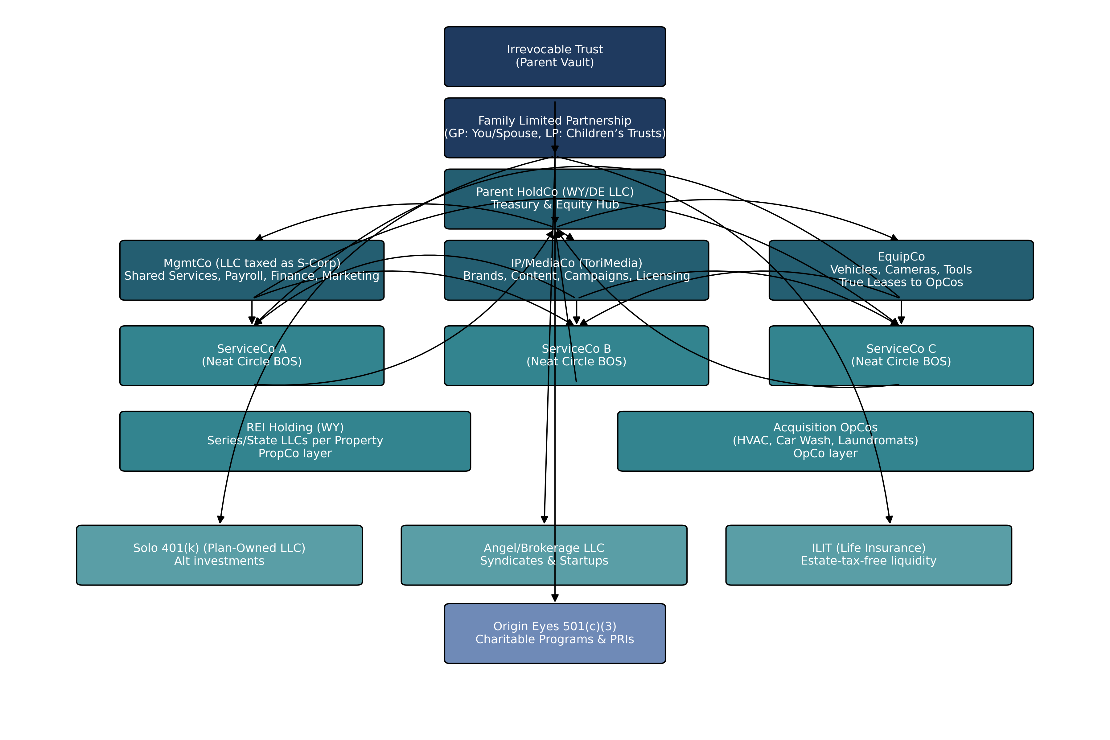

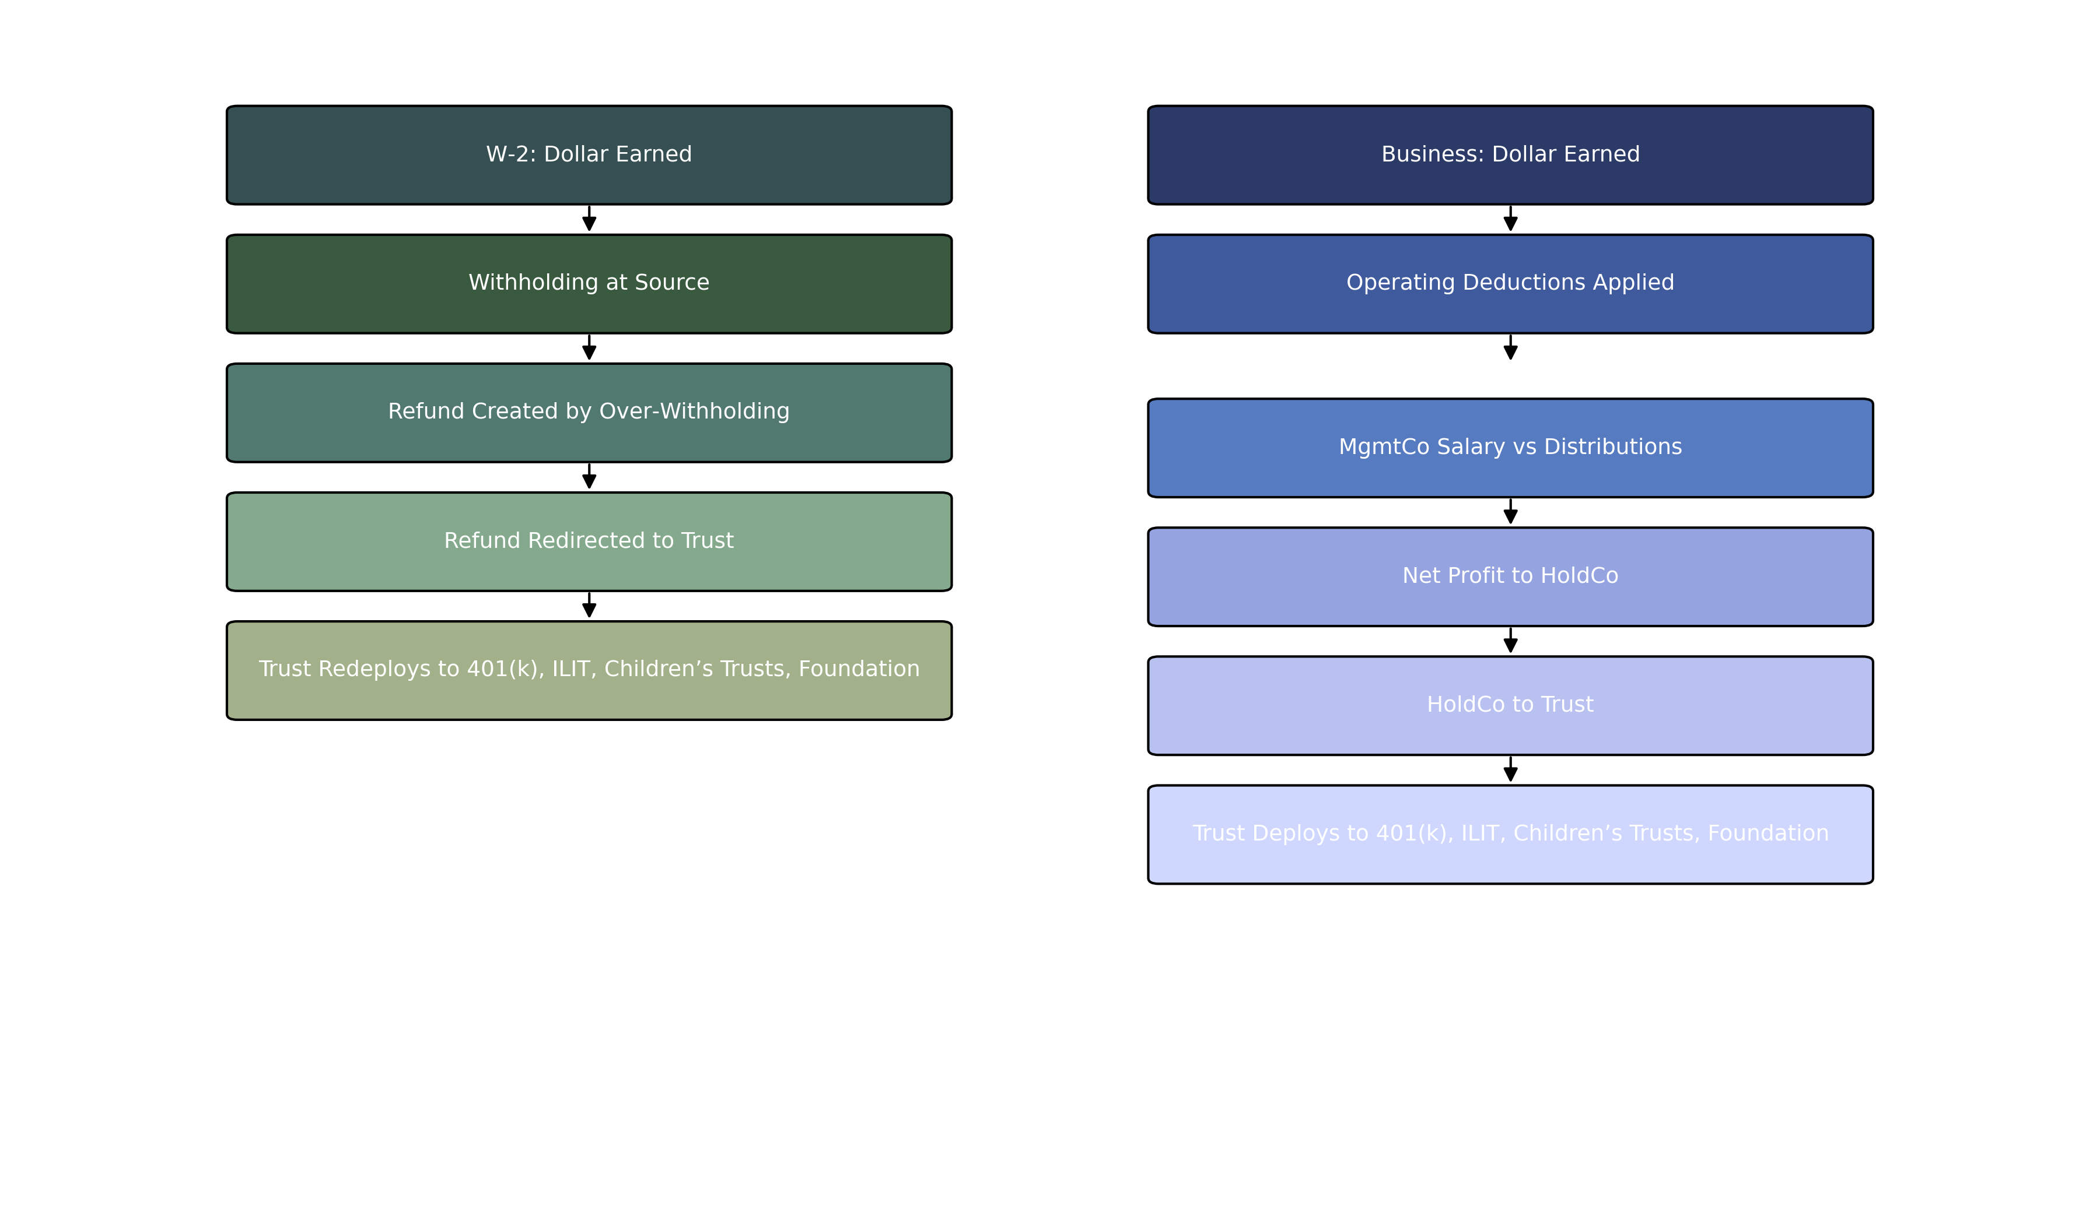

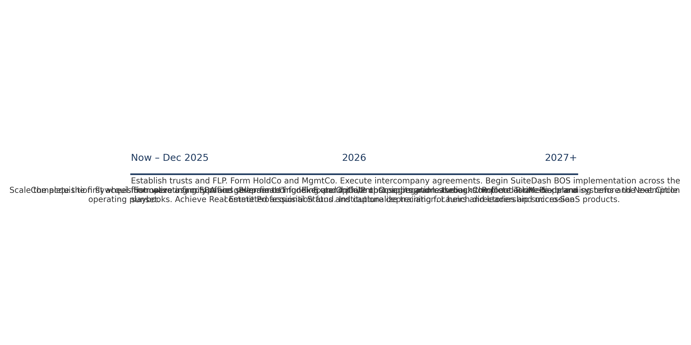

Appendices
Appendix A explains entity formation and banking in the order work actually happens, including drafting of operating agreements, written consents, S‑Corporation elections, EIN assignments, and treasury procedures. Appendix B narrates the intercompany agreements with example clause language for scope, service levels, pricing methods, termination, IP ownership, indemnities, and dispute resolution. Appendix C details SuiteDash implementation with a field‑by‑field data dictionary, role‑based permission scheme, and a sequence of automations from lead capture to invoice collection to support ticket closure. Appendix D presents the acquisition underwriting method, diligence document requests, quality‑of‑earnings checkpoints, financing structures, and the first‑hundred‑days integration plan. Appendix E assembles the compliance calendar for entities, trusts, retirement plans, and the foundation and explains how monthly closes feed into quarterly and annual filings.

Revenue by Segment (USD)
Year | Services | SaaS & Directories | Acquired OpCos | PropCo Rent | Total Revenue
2026.0 | 1,200,000 | 300,000 | 4,000,000 | 320,000 | 5,820,000
2027.0 | 1,500,000 | 480,000 | 11,200,000 | 896,000 | 14,076,000
2028.0 | 1,800,000 | 720,000 | 21,760,000 | 1,740,800 | 26,020,800
2029.0 | 2,124,000 | 1,008,000 | 35,848,000 | 2,867,840 | 41,847,840
2030.0 | 2,442,600 | 1,360,800 | 52,640,400 | 4,211,232 | 60,655,032

EBITDA by Segment and Total (USD)
Year | Services EBITDA | SaaS EBITDA | OpCos EBITDA | PropCo EBITDA | Total EBITDA
2026.0 | 300,000 | 165,000 | 720,000 | 176,000 | 1,361,000
2027.0 | 405,000 | 278,400 | 2,240,000 | 492,800 | 3,416,200
2028.0 | 504,000 | 432,000 | 4,569,600 | 957,440 | 6,463,040
2029.0 | 594,720 | 624,960 | 7,886,560 | 1,577,312 | 10,683,552
2030.0 | 732,780 | 884,520 | 11,580,888 | 2,316,178 | 15,514,366

Free Cash Flow, Interest and Capex (USD)
Year | Interest | Capex | FCF (Base) | FCF (Downside) | FCF (Upside)
2026.0 | 1,000,000 | 116,400 | 179,620 | 165,180 | 190,450
2027.0 | 850,000 | 281,520 | 1,822,764 | 1,694,454 | 1,874,088
2028.0 | 700,000 | 520,416 | 4,147,646 | 3,859,494 | 4,320,538
2029.0 | 550,000 | 836,957 | 7,269,885 | 6,763,207 | 7,573,891
2030.0 | 400,000 | 1,213,101 | 10,878,392 | 10,122,674 | 11,331,823

